## 



MSc Data Science

Cardiff Metropolitan University

Module Leader: Dr Sia, Chow Siing

"Comparative Sentiment Analysis of Vodafone and Three Trust Pilot Reviews: Evaluating Customer Perceptions."

**Student ID: 20288240**

**Name: Vignesh Alluri**

**Course: Social Media Analytics for Business** **Code: CIS7029**

**BIOGRAPHY**

Hi there! My name is Vignesh Alluri, and I'm a creative person that loves to connect with others and learn new things. birthplace and upbringing: Nellore, India. I successfully finished my bioinformatics bachelor's degree at Vignan University in India. I have solid experience with CRM tools and data analytics, which will help me finish this course. My career has been thriving at Cognizant, where I have contributed my CRM and visualisation abilities for more than a year and a half. Furthermore, I believe that I have a great sense of passion and commitment to completing my master's degree in data science. Because of my superior technical skills and comprehension of several technical areas

**TABLE OF CONTENTS**

**1.****INTRODUCTION** **5-6**

1.1- Introduction …………………………………..……………………………………………………………………………………….5

1.2 – Abstract …………………………………………………………………………………………………………………..……………5

1.3 – Purpose ………………….…………………………………………………………………………………………………………….5

1.4 – Approach ………………………………………………………………………………………………………………………………6

1.5 – Findings…………………………………………………………………………………………………………………………………6

**2.DATA PREPROCESSING…………….……………………………………………….7-10**

2.1Api………………………………………………………………………………………………...7

2.2 Design……………………………………………………………………………………………7

2.3 Tools and Technologies………………………………………………………………………......7

2.4 Process of Data Scrapping……………………………………………………………………8-10

**3.DATA CLEANING AND VISUALIZATION……………………......………………….11**

3.1 NLP……………………………………………………………………………………………...11

3.2 Sentiment analysis ………………………………………………………………………………11

3.3 Summery………………………………………………………………………………………...11

**4.KEY RESULTS………………………………………………………………………..12-16**

**5.STORY AND INSIGHTS…………………………………………………………………17**

5.1 Business Story…………………………………………………………………………………...17

5.2Client Relationships……………………………………………………………………………..17

5.3 Enhancement…………………………………………………………………………………….17

5.4 Strategic Recommendations……………………………………………………………………..17

**6.CONCLUSION……………………………………………………………………………18**

6.1 Project Limitation……………………………………………………………………………….18

6.2 Recommendation………………………………………………………………………………..18

**7.REFERENCES……………………………………………………………………………19**

**8.APPENDICES………………………………………………………………………....20-21**

**List of Figures**

Figure 1: Approach 12

Figure 2: Percentage of Ratings 12

Figure 3: Total Reviews 12

Figure 4: Reviews By Month 13

Figure 5: Geographical View of Total Reviews 13

Figure 6: Sentiment Analysis of Three, Vodafone 14

Figure 7: Average Ratings 14

Figure 8: Sentiment Analysis 15

Figure 9: Cleaned Data With Sentiment Analysis 15

Figure 10: Word Cloud(Three) 16

Figure 11: Word Cloud(Vodafone) 16

# **INTRODUCTION**

## 1.1 - Introduction:

The main features of Vodafone UK and Three UK, two significant telecommunications firms with operations in the United Kingdom, will be compared and examined in this paper. We'll look at their technology platforms, advantages and disadvantages from the standpoints of the market and users Ghafar, Zanyar. (2024). Additionally, we will look at what matters to corporate clients when selecting a telecom service and pinpoint the strategic elements of developing a telecom service selection plan (Lee, Deok-Joo & Ahn, Jae-Kyoung. (2007)). We will examine the quality perception, duration of use, and switch intention of around 3000 customers from both telecom service providers in order to gain insight into their behaviour and loyalty to the individual organisations.

This study will compare and analyse the key characteristics of Vodafone UK and Three UK, two major telecommunications companies that operate in the United Kingdom. We'll examine their technical architectures, benefits, and drawbacks from the perspectives of consumers and the market. Furthermore, we will look at the factors that corporate customers consider when choosing a telecom service and identify the strategic components of creating a telecom service strategy. In order to obtain insight on the behaviour and loyalty of 803 customers to different telecom service providers, we will analyse their perceptions of quality, length of use, and intention to switch. According to our research, Vodafone UK and Three UK both offer state-of-the-art application services With a multitude of possibilities from which clients can select have a broad range of options.

**1.1.1 Vodafone:**

Vodafone UK is a well-known telecommunications company that provides millions of consumers around the UK with a wide range of services, including TV, broadband, and mobile. Vodafone UK provides both urban and rural locations with dependable connectivity and high-speed internet access thanks to its vast coverage and solid network infrastructure. The company's adoption of cutting-edge technologies, including 5G, which enable higher data rates and richer digital experiences for users, is indicative of its commitment to innovation.

1.1.2 Three:

Three UK, a well-known telecom company, has received a wide spectrum of feedback from its users on websites such as Trustpilot. Some consumers praise Three UK for its enticing data bundles, competitive pricing, and network coverage, while others are frustrated by problems with billing disparities, network dependability, and customer service. Three UK keeps innovating and investing in its network infrastructure, even in the face of criticism, with the goal of providing better services and experiences for its customers. Focused on satisfying customer needs, increasing transparency, and preserving a competitive advantage in the telecom sector, Three UK works to overcome obstacles and establish itself as the UK's top supplier of internet and mobile services.

1.2 Abstract:

Sentiment analysis extracts emotions from text and is an essential part of natural language processing. Its importance, techniques, and applications are highlighted in this abstract. Sentiment analysis uses machine learning algorithms to extract sentiments from large amounts of textual data, which helps decision-makers in a variety of fields, including customer service, marketing, and finance. The development of sentiment analysis methods, such as deep learning models and lexicon-based strategies, is examined in this work. It also looks into problems like context awareness and sarcasm recognition. Liu, B. (2012). This research offers suggestions for future research areas and advances sentiment analysis approaches through thorough examination.

### 1.3 Purpose:

In order to determine areas for development in the telecommunications industry and to assess consumer happiness, Vodafone and Three evaluations were chosen for sentiment analysis. Through the analysis of user opinions on sites such as Trustpilot, information about Vodafone and Three's overall user experience, customer service, and network dependability may be gleaned. These businesses may better adjust their tactics to satisfy client wants, build brand recognition, and eventually increase customer loyalty by knowing the attitudes of their customers. Sentiment analysis provides useful information that may be applied to improve customer interactions and service optimisation.

### 1.4 Approach:

We need to follow methodical approach to sentiment analysis of Vodafone and Three reviews on Trustpilot. First, we need to compile a sample of reviews that are indicative of both businesses. After that, we need to preprocess the data to standardise the text format and eliminate noise. Next, by utilising natural language processing methods, we need to examine the tone that the reviews convey. Lastly, we will analyse the data to determine how customers feel about Three and Vodafone generally

To perform analysis on customer reviews, I have to perform social media analytics. For this, I have used the following tools and platforms.

* + - Trustpilot for customer reviews
    - Instant Data Scrapper for data scrapping
    - Python NLTK for Sentiment Analysis Python NLTK for Sentiment Analysis
    - Tableau for data visualizations





Figure 1 Approach

### 1.5 Findings:

Analysing Vodafone and three Trustpilot reviews yields valuable insights regarding customer sentiment. Positive emotions are often derived from excellent customer service, dependable network coverage, and effective communication. Unsatisfactory service interactions, network issues, and price concerns are typically the causes of bad sentiments. Acknowledging these emotions can help both companies identify areas for improvement and prioritise actions to increase customer satisfaction and loyalty.

## 2.PRE PROCESSING OF DATA

1. JUPYTER NOTEBOOK: This is an interactive tool for data analysis and exploration that also allows for interface visualisation.  
2. SEABORN, MATPLOTLIB: By creating a graph and conducting analysis, the libraries are utilised to visualise the extracted data. Through correlation and heat mapping, we are also able to comprehend the link between the columns. makes the insights' graphic representation.   
3.TABLEAU: This user-friendly platform allows you to develop data dashboards to gain more business insights and comprehend the viewpoint of the processed data.

### 2.1API’s:

###### NLP API’s:

These are used for the sentimental analysis by categorising the data into positive, negative, neutral. Natural language processing can be done based for the speech recognition.

**2.2 DESIGN**

In order to gather, analyse, and analyse the relevant data for designing and developing enterprise social media analytics systems, it is critical to rely on a range of data sources, tools, and APIs.

#### 2.2.1SOCIAL MEDIA PLATFORMS:

Trustpilot**:**

* Trustpilot stars are more than simply a rating; they are a statement to the world that customers genuinely adore your business and that you reciprocate. It provides a rich dataset for sentiment analysis by offering a varied spectrum of viewpoints.
* From trust pilot I have scrapped user reviews, ratings and date of the reviews for Vodafone and three networks.

**2.3 TOOLS & TECHNOLOGIES:**

WEB SCRAPING TOOLS:

**1.** Bright Data (Luminati Networks)

With its customizable dashboard and the capability to structure data sets of any size, Bright Data provides fully compliant and risk-free access to robust data. Bright Data web scrapers are geared toward any type of customer or use case

**2.**Scraper API

Scraper API is one of the easier web scraping tools for non-developers to integrate, as all it requires is an API key and URL for a user to send a GET request. Lending easy support for JavaScript renderings, Scraper API is also fully customizable and allows for the request as well as the header to be tailored to a user’s needs.

**3.**Octoparse

For the non-developers out there looking for an easy, usable web scraping tool that requires no code, Octoparse might fit the bill. In addition to desirable features like IP rotation and cloud storage services

**4.**instant data scraper:

Instant Data Scraper is a Chrome addon that is free to use. It enables the extraction of data from websites. You may export and save it to Excel as well. It's only do-it-yourself.

# **2.4 The process of the Data Scarping:**

## Step 1: Install

Install I[nstant Data Scrapper](https://chrome.google.com/webstore/detail/instant-data-scraper/ofaokhiedipichpaobibbnahnkdoiiah?hl=en-US)as a Chrome extension by clicking on “Add to Chrome” and the “Add Extension” button that will pop up immediately after.

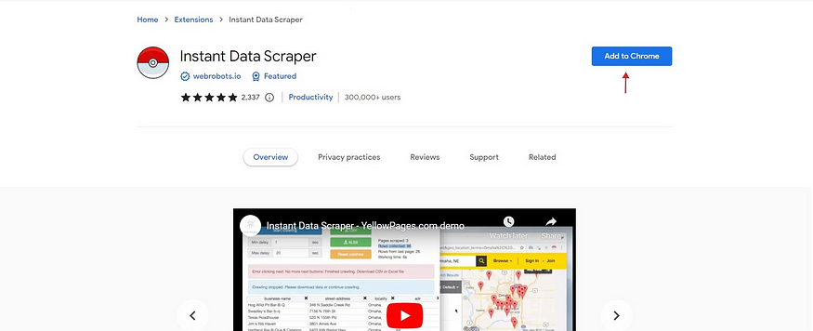

Now let’s start extracting…

## Step 2: Extracting your data

We are going to use the trust pilot website to scrap the data.

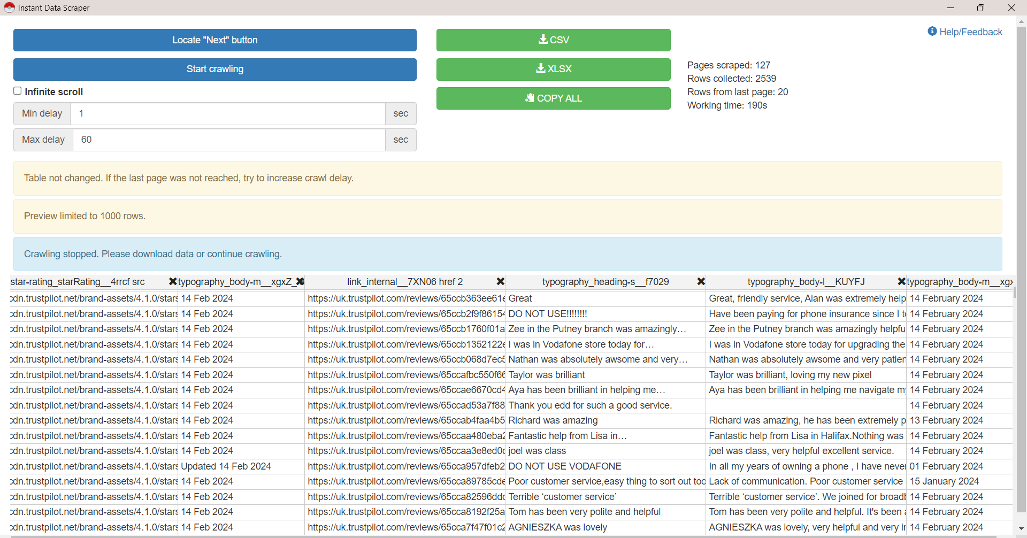

The goal now is to extract the data from the website and convert it into a spreadsheet so it is in a readable format that can be manipulated.Once you’ve opened the page, use the Chrome extension which you’ll find by clicking on the puzzle icon on the top right-hand corner of your browser.

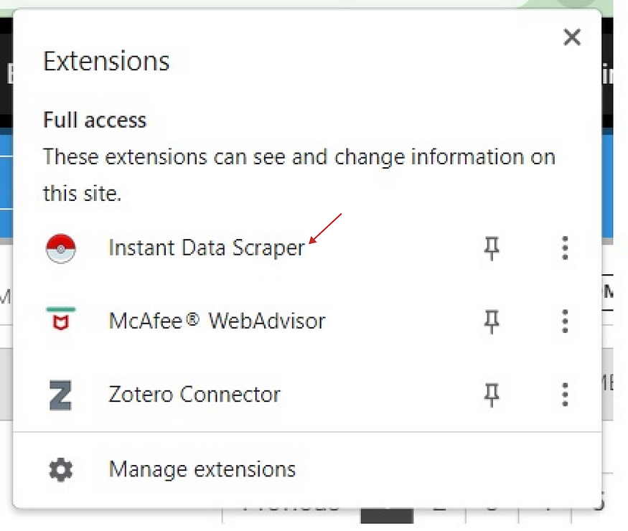

Once you’ve clicked on the extension, it will present the data in this format (below), and you can do quite a few things with it before downloading.

Use the cross on the top right-hand corner of each column to remove any column you don’t want. If you mistakenly delete a column that you need, you can click “Reset All” to restore all the columns in the original format.

## Step 3: Getting your data

Once you are satisfied with your data, take it into your spreadsheet by clicking on “Copy All” and then paste it. Or you download it as a CSV or XLSX.

## ****Step 4: Using the data****



Once you’ve got the data in a spreadsheet, you can use our [spreadsheet formulas](https://inside.mediahack.co.za/five-essential-and-super-simple-spreadsheet-formulas-every-journalist-needs-to-know-4d8bf89251d) or [spreadsheet functions](https://inside.mediahack.co.za/five-more-simple-spreadsheet-functions-every-journalist-needs-to-know-72495dbf96df) guide to manipulate the data. Check out our [Flourish and Figma](https://inside.mediahack.co.za/getting-started-with-flourish-figma-to-create-beautiful-custom-charts-34e4efb8fd3d) guide to create custom charts using the data you’ve just extracted and manipulated.

### 3.DATA CLEANING AND VISUALISATION

**3.1 NLP API’s:**

It is used for the sentimental analysis of the data by arranging the data into positive, neutral, negative.

“Preparing and "cleaning" text data for machine analysis is known as data pre-processing. Pre-processing identifies textual elements that an algorithm may use and transforms data into a format that is manageable. Speech recognition can be the basis for natural language processing (Lutkevich & Burns, 2023). When there is a by the packages, text analysis can be performed.

**3.2 Sentiment analysis:**

Sentiment analysis is an application of natural language processing (NLP) that is included in the text categorization domain. Sentiment analysis can be defined as the process of classifying a text into one of several sentiments, such as positive, negative, neutral, or cheerful.

##### Using NLTK:

The analysis of the good, neutral, and negative reviews is done using the scaled data. The following is how we obtain the reviewers' numerical values:   
 -1 for -ve,

+ 1 for +ve   
  
 Neutral is represented with a zero.

##### Using Tableau:

Tableau is a user-friendly tool that allows data visualisation and makes analysis simpler and easier to comprehend. Convert Data into Useful Knowledge.

TextBlob:

Textual data is parsed using TextBlob. For handling common natural language processing (NLP) tasks including sentiment analysis, categorization, noun phrase extraction, part-of-speech tagging, and more, it provides an intuitive API.

**3.3 Summary**

Numerous web scraping technologies improve the system's functionality. Data pre-processing, an essential stage in enhancing the quality of the data, makes use of programmes like Pandas for manipulating data frames, NumPy for numerical analysis, and Python for processing CSV files and noise reduction. Power analysis and visualisation are facilitated using Jupyter Notebook, Matplotlib, Seaborn for graphical representation, and Tableau for easy-to-use dashboard design that offers insights and perspectives on processed data.   
  
Sentiment analysis requires APIs, especially those that deal with Natural Language Processing (NLP). Through the process of categorising data based on positive, negative, and neutral attitudes, they offer an advanced understanding of user-provided content. The selection of tools is justified by factors including effectiveness, scalability, user-friendliness, and capacity for customisation. In conclusion, the holistic approach to system design ensures a strong and adaptable foundation for social media analytics in an organisational setting.

**4.Key Results**

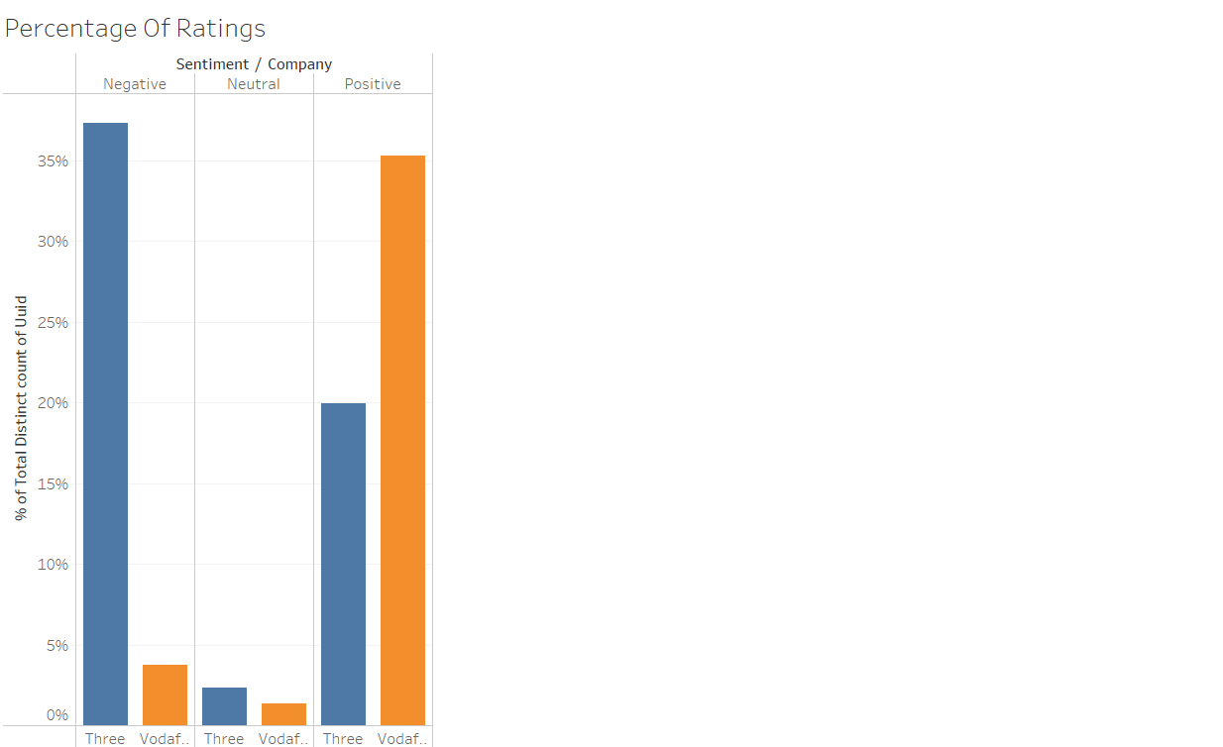

Figure 2 Percentage of Ratings

Sentiment analysis for two companies. "Three" has received more negative and less positive feedback than "Vodafone," which has a noticeably greater percentage of favourable comments. Neutral evaluations are scarce for both companies. According to the research, "Vodafone" is perceived more favourably by customers, whilst "Three" would need to address complaints from customers. The chart shows firm opinions from customers rather than apathy.

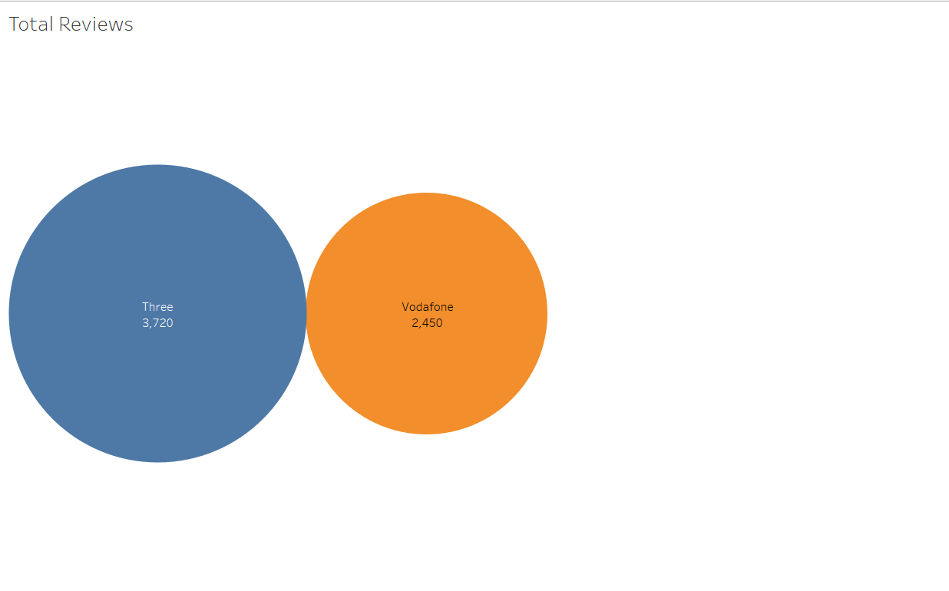

Figure 3 Total Reviews

The distribution of reviews between Three and Vodafone is shown visually in the pie chart. Three's review count (3,779) is substantially larger than Vodafone's (2,583). This implies that Three probably has a greater number of clients or more engaged customers who provide reviews.

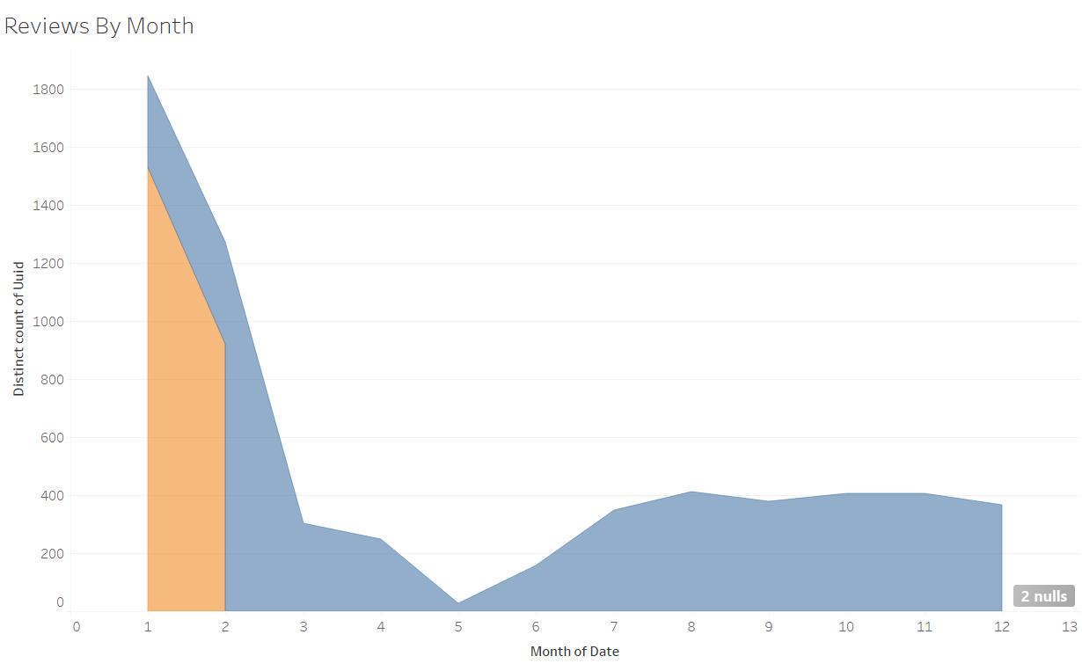

Figure 4 Reviews By Month

This gives Seasonal Trends Over the course of the month, reviews for Three and Vodafone fluctuate.  
Three exhibits a discernible peak approximately four months in advance, indicating a possible event or campaign that attracted more attention. In contrast, Vodafone consistently maintains a higher number of reviews all year round. Comparing Three to Vodafone, the difference in peak is substantial. This would suggest that Three was involved in a significant product launch, marketing campaign, or customer interaction at that time.

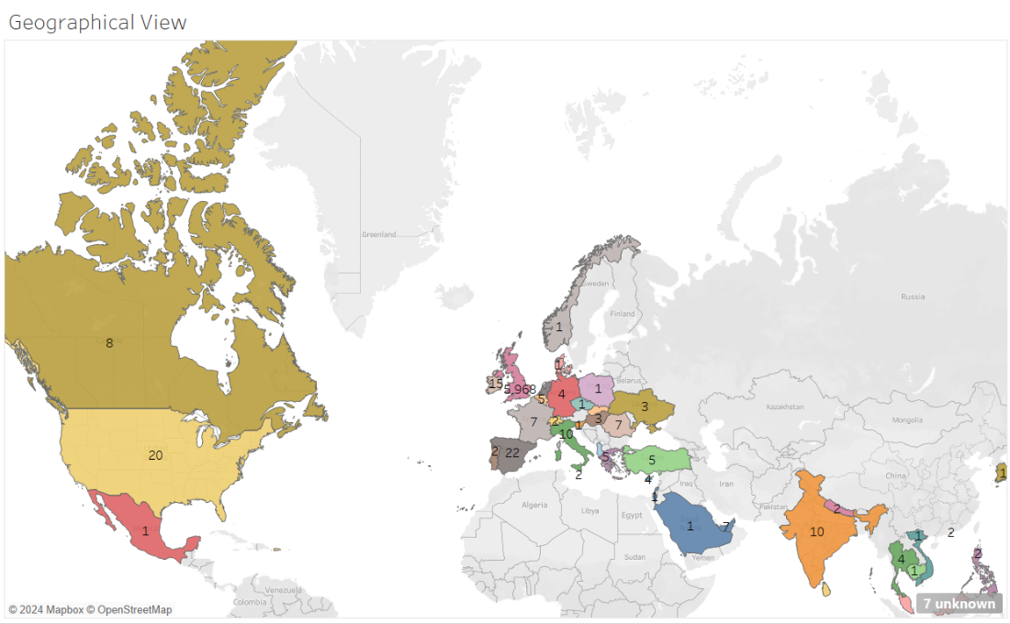

Figure 5 Geographical View of Total Reviews

Customer reviews are geographically represented, suggesting a global reach with input coming from different parts of the world. However, the bulk of reviews are centred in the UK, suggesting a significant presence and potentially a larger clientele in this area. Even with involvement from all over the world, Three and Vodafone still receive the majority of their comments from the UK.

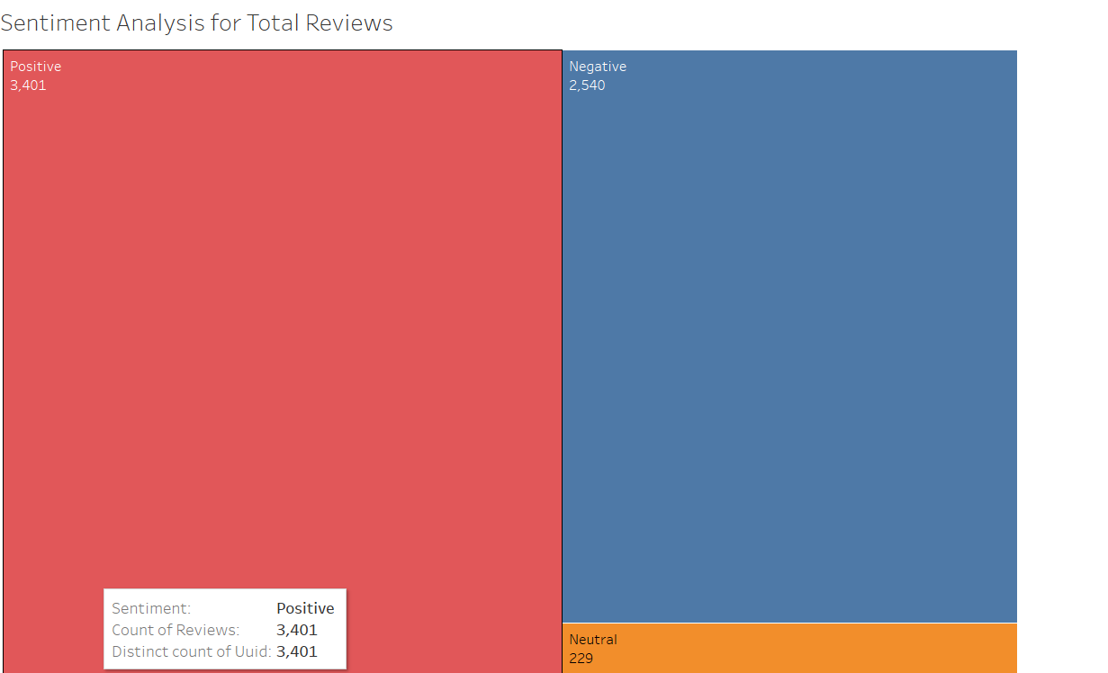

Figure 6 Sentiment Analysis of Three, Vodafone

This is the sentiment analysis of both the companies where we can see that more positive reviews than negative reviews. The majority of positive evaluations for Three and Vodafone are highlighted by this sentiment analysis, indicating that users have a generally positive opinion of both companies. This favourable opinion points to chances to increase brand support and loyalty through focused efforts and an ongoing dedication to client happiness.

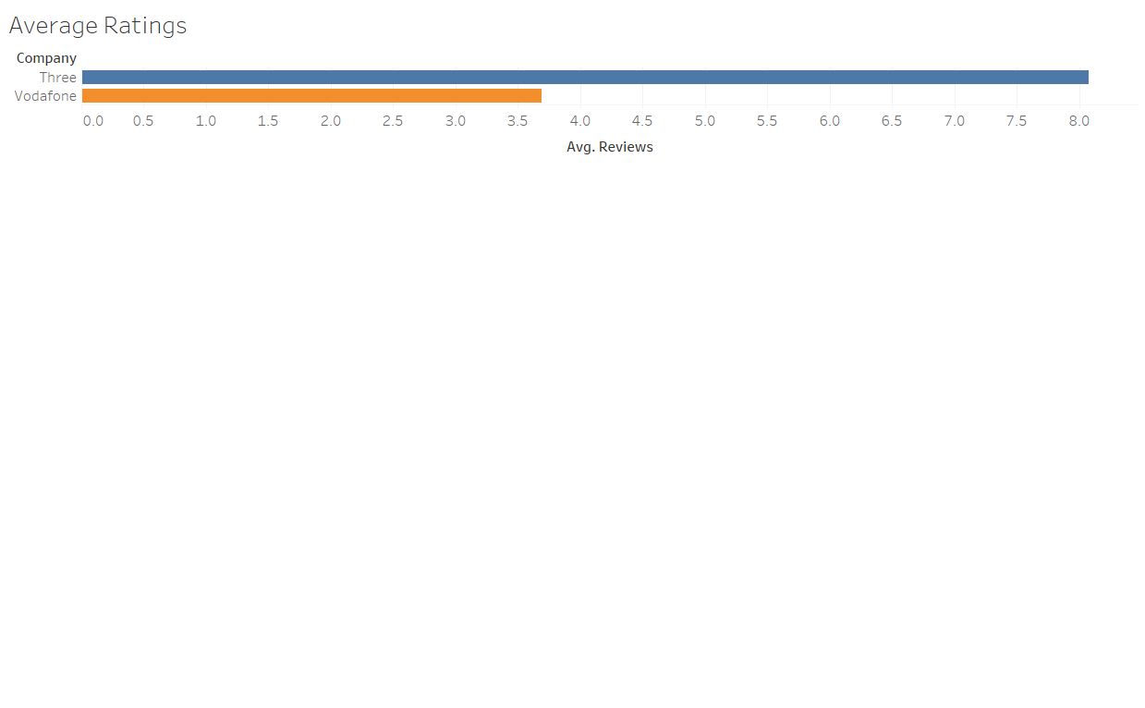

Figure 7 Average Ratings

The analysis's average ratings show an interesting pattern: Three routinely scores higher than Vodafone when it comes to consumer happiness. This discrepancy highlights Three's better than Vodafone performance in fulfilling consumer expectations. These kinds of insights are a critical signal for both businesses, highlighting the necessity for Vodafone to review its approaches in order to better suit client preferences and improve the quality of its services in order to stay competitive.

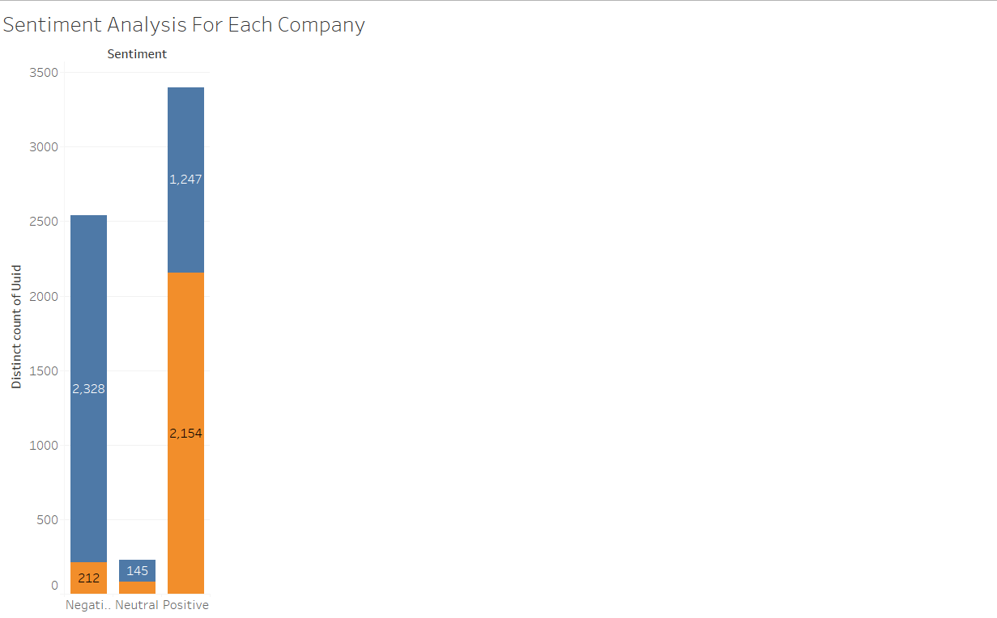

Figure 8 Sentiment Analysis

The sentiment study shows that evaluations for Three and Vodafone are evenly distributed between positive and negative, with a little bias towards the former. This equilibrium suggests that users have a generally positive opinion of both businesses. Remarkably, the closeness of unfavourable evaluations to favourable ones indicates opportunities for development that can be tackled to raise client satisfaction levels overall. Even with a few minor complaints, opinions are still generally good. This gives Vodafone and Three the chance to take use of their advantages and resolve any issues in order to increase customer advocacy and brand loyalty.

**Sentimental Distribution Overview:**

The emotional content of a dataset is summed up in a sentimental distribution overview. It quantifies the frequency of occurrence of common emotions including surprise, joy, sadness, and rage. It offers insights into emotional patterns using sentiment analysis techniques, which helps with comprehending audience responses and informing content strategies for different platforms. The sentiment distribution throughout the data set that was analysed is presented below:

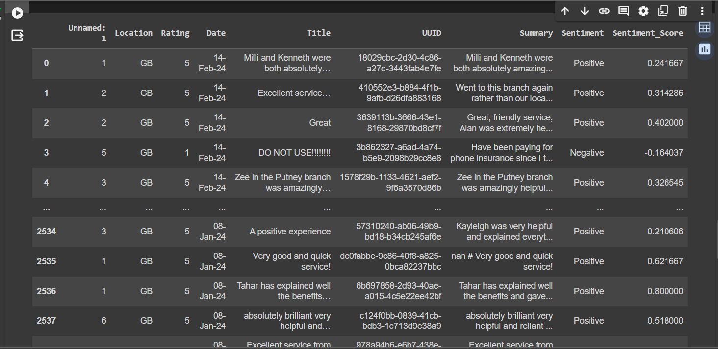

Figure 9 Cleaned Data with Sentiment Analysis

**Word Cloud (Three)**

The word cloud depicts a dissatisfied consumer's interaction with Three's customer support. Frequently occurring phrases such as "told," "contract," "account," "customer service," and "phone" are prevalent and suggest common problems. Words like "out of contract," "did not speak to," "worst service," and "have to cancel" draw attention to unpleasant experiences. In general, it indicates that calling customer care can be difficult when trying to terminate a phone contract.

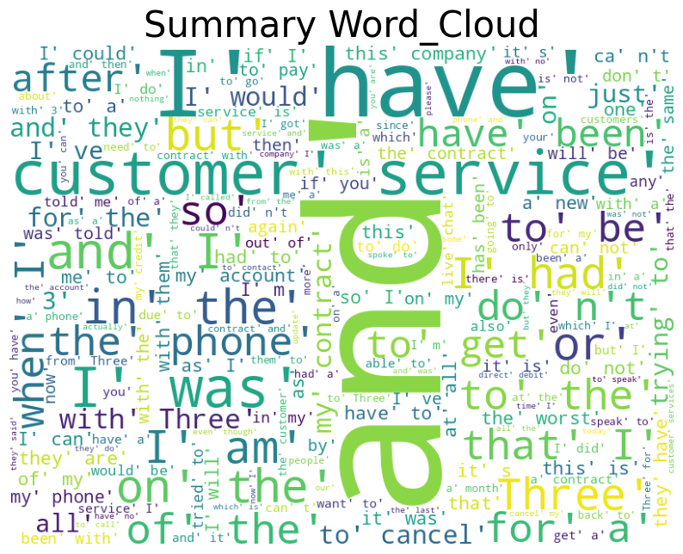

Figure 10 Word Cloud (Three)

**Word Cloud (Vodafone)**

Vodafone's customer feedback word cloud research indicates a strong majority of positive sentiments, with adjectives like "great," "helpful," and "friendly" standing out. Consumers express pleasure with the service and compliment Vodafone employees on their expertise and speed in resolving issues. But it's important to recognise that this data comes from a single source, which may limit its representativeness of the opinions of the total consumer base.

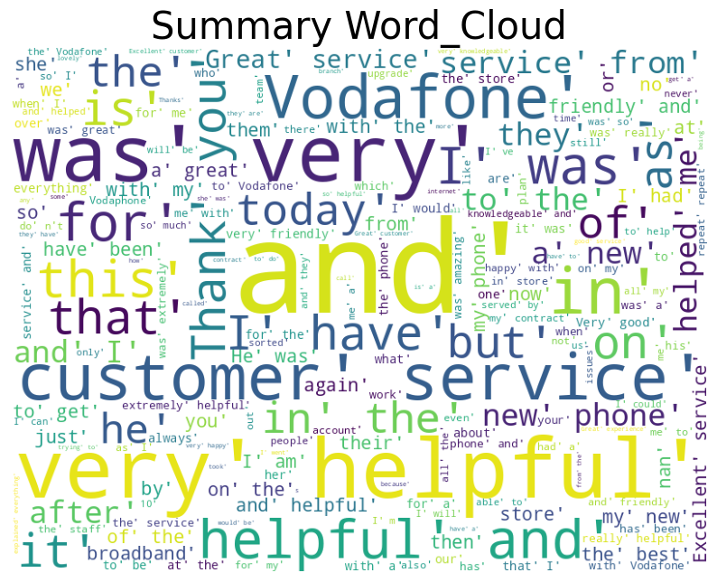

Figure 11 Word Cloud (Vodafone)

**5.STORY AND INSIGHTS**

**5.1 Business Story**

Both businesses have received recognition for different facets of their services, but they also have issues with pricing transparency, customer service, and network dependability. Vodafone and Three should concentrate on putting strategic changes into effect in a number of important areas if they want to keep their competitive edge and raise consumer happiness.

**5.2 Client Relationships**

Enhancing client experiences is of utmost importance to Three and Vodafone. In a market that is becoming more and more competitive, positive customer experiences not only promote brand loyalty but also propel corporate expansion. Customers have praised Vodafone for its stable connectivity and adoption of cutting-edge technology such as 5G. However, several customers have praised Three for its alluring data bundles and affordable prices. Frustration has been brought on, among other things, by problems with billing discrepancies, network dependability, and customer service. To resolve these issues and raise user satisfaction levels overall, both businesses need to place a high priority on timely customer service, transparent communication, and network infrastructure investment.

**5.3 Enhancement**

Vodafone and Three should focus on areas like pricing transparency, customer service responsiveness, and network dependability in order to address customer complaints and enhance overall satisfaction. Both businesses may encourage good change, fortify customer relationships, and preserve a competitive edge in the telecom industry by using sentiment research data and sponsoring strategic initiatives.

**5.4 Strategic Recommendations**

One of the strategic recommendations that Vodafone and Three should prioritise is improving the responsiveness and quality of customer service in order to address the issues that were brought up in the negative evaluations. The entire user experience can also be improved by making investments in network infrastructure upgrades that offer dependable service and quick internet access. Fostering transparent dialogue about pricing adjustments and service enhancements can also boost customer loyalty and trust. Vodafone and Three may fortify their positions in the cutthroat telecom sector and enhance their brand image by putting these suggestions into practice.

**6.CONCLUSION**

Sentiment analysis of Trustpilot evaluations for Vodafone and Three reveals that both businesses have a mixed bag of favourable and unfavourable comments from their users. While some consumers express pleasure with customer service, network stability, and billing concerns, others criticise features including coverage, competitive pricing, and high-quality service. Vodafone and Three can use these insights to concentrate on their areas of strength and make the most of their weaknesses. Enhancing overall user experience and sentiment can be achieved by giving priority to network infrastructure improvements, open communication, and timely customer care. Furthermore, promoting client interaction via loyalty plans and social media can increase advocacy and brand loyalty. Both Vodafone and Three have the chance to foster a more positive attitude among their customer base by attending to consumer issues and fulfilling commitments, which will ultimately resulting in a rise in loyalty and satisfaction. Vodafone and Three may further improve their customer service and prioritise network infrastructure investments by using advanced analytics to obtain deeper insights into client preferences and pain issues. Using this information to implement customised offers and solutions might help them build closer relationships with their user base. Furthermore, it is possible to reduce negative sentiment and improve brand reputation by proactively engaging with disgruntled customers through dedicated support channels and prompt issue resolution. Both businesses may establish long-lasting customer relationships and strengthen their position in the competitive telecoms industry by consistently improving their strategy in response to consumer feedback and market trends.

**6.1 Project limitation**

Here I have data related to Vodafone and three and I cannot able to get more ratings because the reviews are less and cannot able to show the data for long years as the reviews are from limited time period. The research may not fully represent the range of customer opinions or sentiments regarding Vodafone and Three because it is restricted to the data that is available on Trustpilot. Although they might offer more information, other sources of input like social media, forums, or direct polls are not taken into account in this analysis. The analysis results may be skewed by external events or news pertaining to Vodafone, Three, or the telecommunications sector in general. It's critical to take into account these outside variables and how they could affect how the facts are interpreted.

**6.2 Recommendation**

Although both Vodafone and three have overall positive ratings they need to improve as they have negative ratings which are almost equal to positive ratings so both Vodafone and Three networks could give priority to a number of tactics in order to improve user feedback. First off, raising the calibre and responsiveness of customer service can have a favourable effect on user happiness. Providing individualised assistance and swiftly addressing problems can improve the overall experience. Furthermore, open and honest communication on service updates, network enhancements, and price modifications can promote client loyalty and trust. It's also essential to invest in network infrastructure to guarantee dependable coverage and better data rates. Incentives like loyalty points or special deals for loyal clients can help increase satisfaction and promote good ratings. Finally, by actively interacting with clients on social media and asking for input via surveys, brands may project a favourable image by showing that they are dedicated to hearing their concerns and resolving them.

**7.REFERENCES**

1.10 best data scraping tools : https://www.upwork.com/resources/best-web-scraper

2. Ghafar, Zanyar. (2024). The Positive and Negative Aspects of Social media platforms in many Fields, Academic and Non-academic, all over the World in the Digital Era: A Critical Review. JOURNAL OF DIGITAL LEARNING AND DISTANCE EDUCATION. 2. 707-721. 10.56778/jdlde.v2i8.212.

3. Lee, Deok-Joo & Ahn, Jae-Kyoung. (2007). Factors affecting companies' telecommunication service selection strategy. Omega. 35. 486-493. 10.1016/j.omega.2005.09.004.

4.Mhatre, S. (2021, October 18). Text Mining and Sentiment Analysis: Data Visualization in Tableau. Simple Talk. [https://www.red-gate.com/simple-talk/databases/sql-server/bi-sql-](https://www.red-gate.com/simple-talk/databases/sql-server/bi-sql-server/text-mining-and-sentiment-analysis-data-visualization-in-tableau/) [server/text-mining-and-sentiment-analysis-data-visualization-in-tableau/](https://www.red-gate.com/simple-talk/databases/sql-server/bi-sql-server/text-mining-and-sentiment-analysis-data-visualization-in-tableau/)

5.Lutkevich, B., & Burns, E. (2023, January 20). natural language processing (NLP). Enterprise AI. https://www.techtarget.com/searchenterpriseai/definition/natural-languageprocessing-NLP

6.Liu, B. (2012). Sentiment Analysis and Opinion Mining. Morgan & Claypool Publishers.

7. <https://www.simplilearn.com/tutorials/python-tutorial/data-visualization-in-python#:~:text=Matplotlib%20and%20Seaborn%20are%20python,primarily%20used%20for%20statistical%20graphs>.

7. Vodafone Reviews: <https://uk.trustpilot.com/review/www.vodafone.co.uk?page=99>

8. Three Reviews: <https://uk.trustpilot.com/review/www.three.co.uk>

9.Vodafone UK. (n.d.). 5G - Our vision. <https://www.vodafone.co.uk/about-us/about-vodafone-uk>

10. Three UK. (n.d.). About us. <https://www.threemediacentre.co.uk/about-us/>

### Tableau Published Links:

Fig 1: [data analysis | Tableau Public](https://public.tableau.com/app/profile/vignesh.alluri/viz/dataanalysis_17143347927440/Sheet1?publish=yes)

Fig 2: [data analysis | Tableau Public](https://public.tableau.com/app/profile/vignesh.alluri/viz/dataanalysis_17143347927440/Dashboard1?publish=yes)

Fig 3: [data analysis | Tableau Public](https://public.tableau.com/app/profile/vignesh.alluri/viz/dataanalysis_17143347927440/Sheet4?publish=yes)

Fig 4: [data analysis | Tableau Public](https://public.tableau.com/app/profile/vignesh.alluri/viz/dataanalysis_17143347927440/Sheet5?publish=yes)

Fig 5: [data analysis | Tableau Public](https://public.tableau.com/app/profile/vignesh.alluri/viz/dataanalysis_17143347927440/Sheet6?publish=yes)

Fig 6: [data analysis | Tableau Public](https://public.tableau.com/app/profile/vignesh.alluri/viz/dataanalysis_17143347927440/Sheet6?publish=yes)

Fig 7: [data analysis | Tableau Public](https://public.tableau.com/app/profile/vignesh.alluri/viz/dataanalysis_17143347927440/Sheet8?publish=yes)

### 8.APPENDICES

### from google.colab import files

### import pandas as pd

### import numpy as np

### import uuid

### import string

### import re

### import nltk

### import math

### import matplotlib.pyplot as plt

### from transformers import pipeline

### from nltk.corpus import stopwords

### from nltk.stem import WordNetLemmatizer

### from nltk.tokenize import word_tokenize

### from nltk.corpus import wordnet

### # Read the CSV file into a pandas DataFrame

### df = pd.read_csv('uk (6) (1).csv')

### df

### df.isnull().sum()

### import uuid

### df['UUID'] = [uuid.uuid4() for _ in range(len(df))]

### df = df.drop('Name', axis=1)

### df['Summary'] = df['Comments'].astype(str) + ' # ' + df['Title'].astype(str)

### df = df.drop('Comments', axis=1)

### df = df.drop_duplicates(subset=['Summary'], keep='first')

### import nltk

### nltk.download('stopwords')

### nltk.download('wordnet')

### nltk.download('punkt')

### nltk.download('averaged_perceptron_tagger')

### nltk.download('vader_lexicon')

### from nltk.tokenize import word_tokenize

### from textblob import TextBlob

### import re

### for index, row in df.iterrows():

### text = row['Summary']

### #lowercae

### text = text.lower()

### #remove punctuations

### text = re.sub(r'[^a-zA-Z\s]', '', text, re.I|re.A)

### #sentiment analysis

### analysis = TextBlob(str(text))

### if analysis.sentiment.polarity > 0:

### sentiment_label = 'Positive'

### elif analysis.sentiment.polarity == 0:

### sentiment_label = 'Neutral'

### else:

### sentiment_label = 'Negative'

### df.at[index, 'Sentiment'] = sentiment_label

### df.at[index, 'Sentiment_Score'] = analysis.sentiment.polarity

### # Save the DataFrame back to the CSV file

### df.to_csv('results.csv', index=False)